What is HTML?

HTML Stands for **Hyper Text Markup Language**. It is not a programming language but a language of browsers. The **World Wide Web Consortium** creates standards of HTML. HTML use CSS to style Html page.

* HTML describes the structure of pages.
* HTML Uses Elements to describe the structure of pages.
* HTML pages are text documents.
* HTML uses tags (characters that sit inside angled brackets) to give the information they surround special meaning.
* Tags are often referred to as elements.
* Tags usually come in pairs. The opening tag denotes the start of a piece of content; the closing tag denotes the end.
* Opening tags can carry attributes, which tell us more about the content of that element.
* Attributes require a name and a value.
* To learn HTML you need to know what tags are available for you to use, what they do, and where they can go.

What is Tag?

Tags act like containers. They tell you something about the information that lies between their opening and closing tags.

**See the example of open and closing tags**

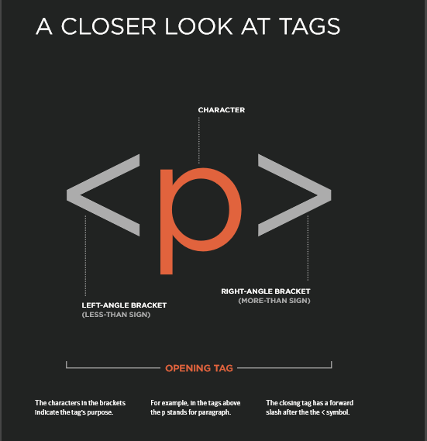

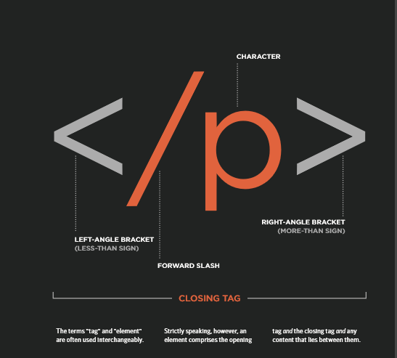

What are Attributes?

Attributes provide additional information about the contents of an element. They appear on the opening tag of the element and are made up of two parts: a name and a value, separated by an equals sign.

The attribute name indicates what kind of extra information you are supplying about the element's content. It should be written in lowercase.

The value is the information or setting for the attribute. It should be placed in double quotes. Different attributes can have different values.

**Example of attributes:**

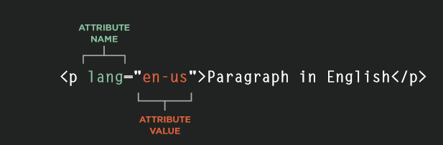

**Simple Page Structure of HTML Document**

**<html>**

**<head>**

**<title>This is the Title of the Page</title>**

**</head>**

**<body>**

**</body>**

**</html>**

BODY HEAD AND TITLE:

**<body>**

Everything inside this element is shown inside the main browser window.

**<head>**

Before the <body> element you will often see a <head> element. This contains information about the page (rather than information that is shown within the main part of the browser window that is highlighted in blue on the opposite page). You will usually find a <title> element inside the <head> element.

**<title>**

The contents of the <title> element are either shown in the top of the browser, above where you usually type in the URL of the page you want to visit, or on the tab for that page (if your browser uses tabs to allow you to view multiple pages at the same time).